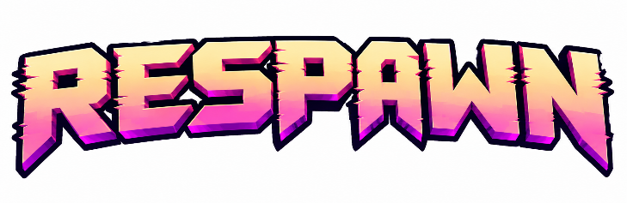
GAME DOCUMENTATION

Team Details

- Team Number: 16
________________________________________________________________________________
- Team Name: Lux
________________________________________________________________________________
- Team Lead Name: Neha Anna John
________________________________________________________________________________

Game Description

- Game Title and Genre:
VIBGYOR — a 2D story-driven, multi-genre puzzle adventure. Every level is a different genre: chess puzzle, physics puzzle-platformer, trick-shot shooter, space-flight physics, survival-horror maze, typing-rhythm, rage platformer and a fighting game.
- Brief Description — explain the concept and objective of your game:
Intro (12-panel comic with comical animation). Thanos has five Infinity Stones in his Gauntlet. He fights Vision, tears the final stone from his head and slots it in, and energy surges through him. Then a giant “TARIFFS” text crashes onto his head and flattens him. Trump appears: “We had spent a lot of money on making Vision, you will pay for it. You took my vision, now I will take yours.” His bodyguards inject Thanos and he blacks out. He wakes up with his vision gone, sees “Donald’s Eye Clinic” in the distance and a Trump-like figure outside, which turns out to be Donald Duck with Trump’s hairstyle. Thanos walks through the clinic door, and Level 1 begins.
Objective. Inside the clinic every world is drawn in a single colour. Playing as Thanos, the player beats each world’s challenge and walks through its Phase Door to the next, starting in black and white and winning back sight one colour at a time:
World | Genre | Challenge
BnW (2 levels) | Chess puzzle | Play Black and find the only winning line (a smothered mate in 4, then a mate in 3), 2 minutes per board. Wrong moves are punished.
BLUE (3 levels) | Underwater puzzle-platformer | Solve A+B=11, B+C=13, A+C=10, confirm the weights on a torque balance and press switches lightest to heaviest; count the triangles in an overlapping figure; crack a remainder lock. One shared 3-minute flood clock.
VIOLET | Neon trick-shot shooter | Destroy three drones with five gravity-bound bullets, then bend a trick shot into the hidden Phase Door.
INDIGO | Space-flight physics | Pilot a ship with thrust and inertia through four zones, swinging around gravity wells on tether anchors to reach the Indigo Gate.
GREEN | Survival-horror maze | With only a flashlight, collect three runes in a night forest while a phantom hunts by sound, then enter the giant tree.
ORANGE | Typing-rhythm dance | Type sentences at 40+ WPM and 88%+ accuracy for 60 s. Every correct key is a dance move for Thanos.
RED | Rage platformer | Four rooms that break their own rules: shy platforms, low gravity (×0.45), left/right swapping every 3 s, and a 7-second laser patience test.
YELLOW | 2D fighting game | Defeat Wolverine with gauntlet jabs, sword combos, dodges and a charged Solar Flash, then step through the Phase Door.

- Connection to the Mystery Theme — how does your game interpret the given theme?
The theme is Sci-Fi: a comic-book sci-fi story that the player travels through, world by world.
– A sci-fi premise: the Infinity Stones, a fight with Vision (an android that, in our story, Trump paid to build), an injection that steals Thanos’s sight, and an eye clinic that must restore it.
– Sci-fi travel between worlds: every level ends at a Phase Door, a portal into the next dimension. Each dimension is drawn in a single colour, starting in black and white, and Thanos regains his vision one colour at a time.
– Sci-fi settings: a flooding underwater research lab (BLUE), a neon facility guarded by security drones (VIOLET), deep space with a singularity and gravity wells (INDIGO), a club under a neon Infinity Gauntlet sign (ORANGE), laser corridors and rooms where gravity and controls glitch (RED), and a throne room with a cosmic window where Thanos fights Wolverine with a Solar Flash (YELLOW).
– Science as gameplay: algebra, torque, geometry and modular arithmetic (BLUE), projectile motion (VIOLET), orbital mechanics (INDIGO), ray-cast lighting and a BFS-checked maze (GREEN), rates and percentages (ORANGE).

Technical Details

- Tech Stack — game engine, programming language, and tools used:
– Platform: Web (desktop browser). Languages: TypeScript, JavaScript (JSX), Python.
– Web stack (every world): React 18 + Vite 5 + Tailwind CSS 3, with custom HTML5 Canvas 2D renderers on a fixed 60 Hz game loop; Framer Motion and Lucide icons for menus.
– Game engine: Phaser 3.90 (Arcade Physics) for RED. BnW is a single React component that also builds into a double-click play.html.
– Python prototypes: VIOLET, INDIGO, GREEN, ORANGE and YELLOW were first built in pygame / pygame-ce, then ported to the web with identical gameplay.
– Audio: Web Audio API. All sound effects and music are synthesized in code.
– Testing and tools: Vitest unit tests (maths, physics, AI, timers, palettes), python-chess to verify the chess puzzles, Node.js, Git and GitHub (one branch per world).
- AI Tools Used — mention the tools and how they were used
– Claude Code (Anthropic, Claude Opus 5.5): AI pair programmer used to scaffold each world, implement game logic, physics and enemy AI, write unit tests, port the Python prototypes to the web, and clean up the READMEs. The team designed the levels and puzzles and reviewed and play-tested everything it produced.
– Intro storyboard images: DaVinci Resolve 21 to create the game intro sequence.
- Repository / Libraries / External Resources — provide links and mention any libraries or assets used:
– Repository: https://github.com/neha-aj/Respawn (branches main/bnw, blue, violet, indigo, green, orange, red, yellow; each world branch merges the one before it).
– Libraries: react, react-dom, vite, typescript, tailwindcss, postcss, autoprefixer, framer-motion, lucide-react, phaser, vitest; pygame / pygame-ce; python-chess (puzzle verification only).
– Fonts (open-source, SIL OFL): Press Start 2P, VT323, Orbitron, Exo 2, IM Fell English SC, Special Elite, IBM Plex Mono (via @fontsource), IM Fell English (Google Fonts).
– Assets: no third-party art or audio. All in-game graphics, pixel fonts, sound effects and music are generated procedurally in code.

Game Screenshots
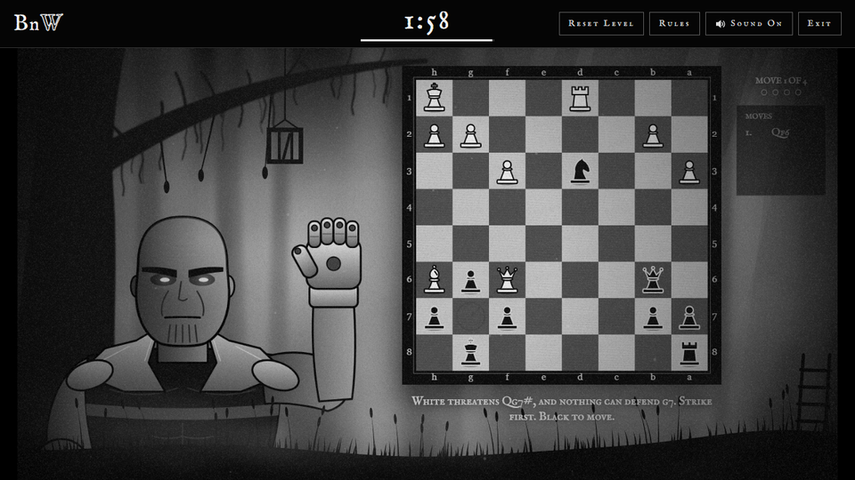  BnW — Level 1 chess puzzle, Thanos plays Black | 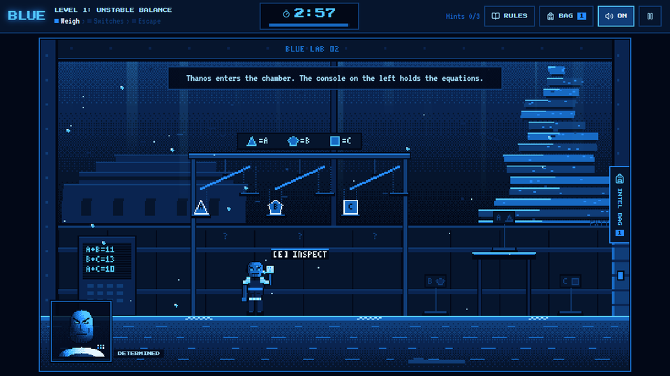  BLUE — the balance chamber and equation console
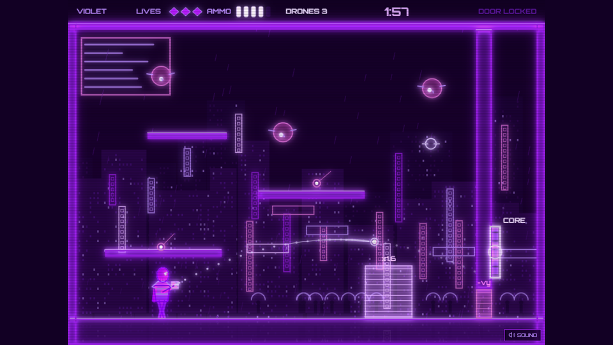  VIOLET — trick-shot arena with drones | 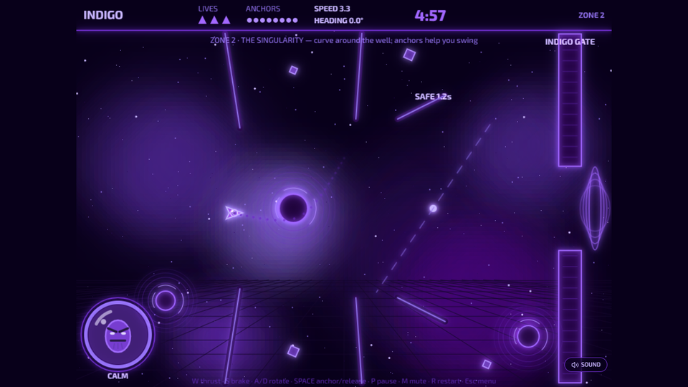  INDIGO — piloting past a singularity
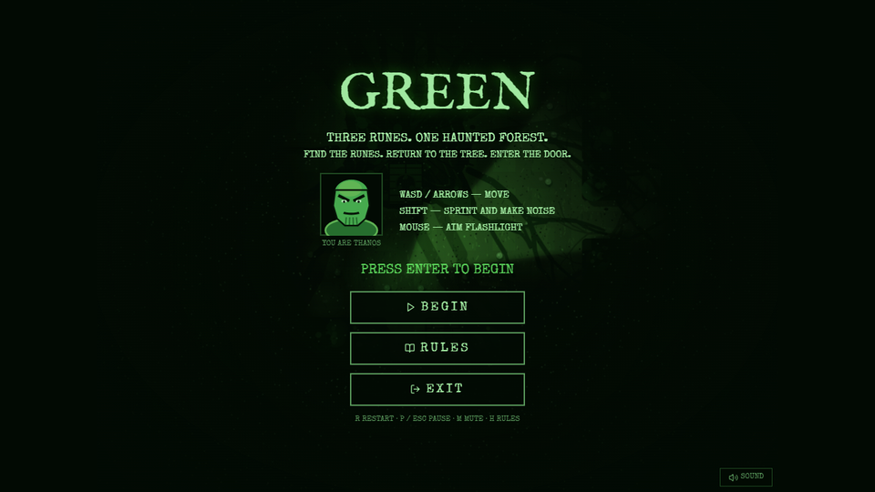  GREEN — title screen of the haunted forest maze | 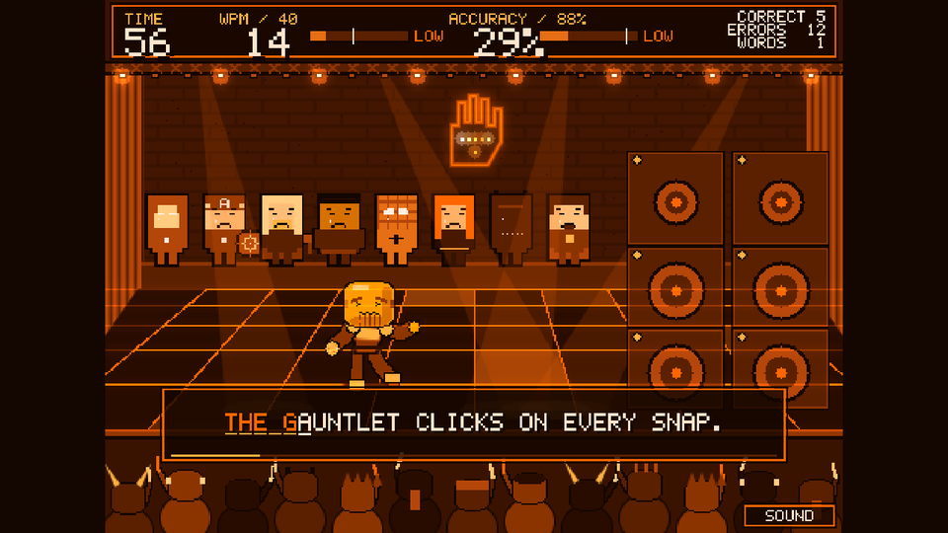  ORANGE — typing makes Thanos dance
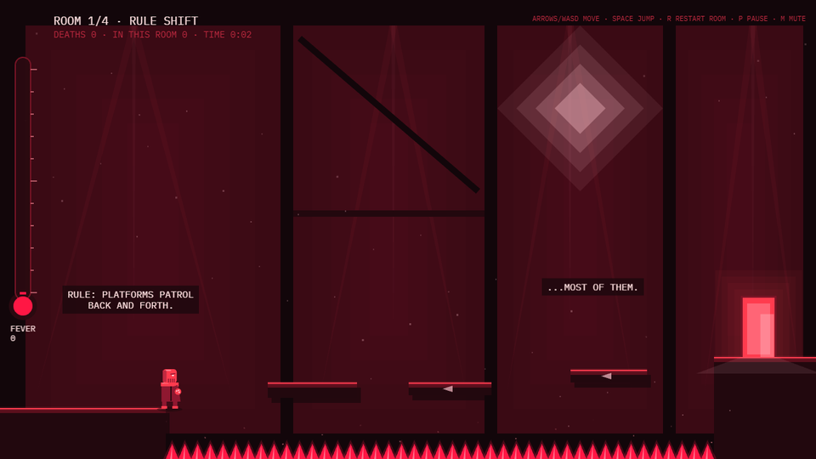  RED — Room 1: Rule Shift | 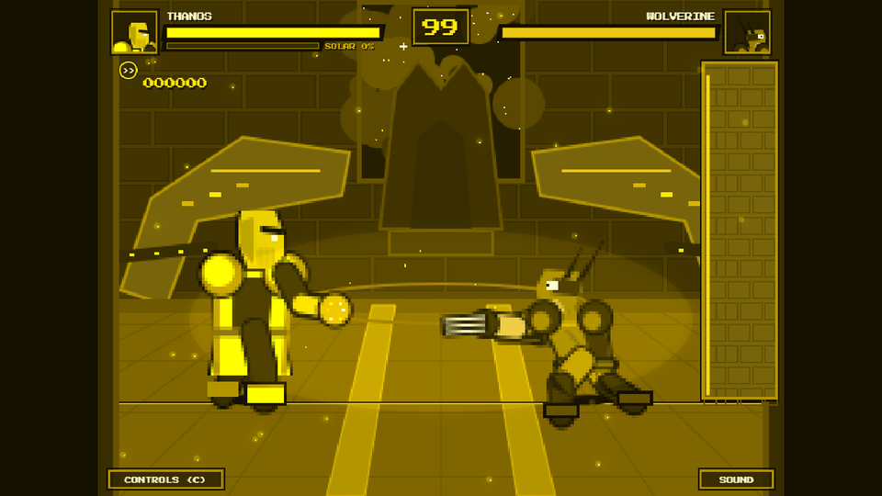  YELLOW — Thanos vs Wolverine

